Calling ALL St. Polycarp Families…
Please take part in our…
PSR Christmas Ornament Fundraiser
This “New” Fundraiser is to support our program. There are many expenses each year that tuition fees alone do not cover. This fundraiser will help with costs.
We are selling “Limited Edition” Christmas Ornaments.
Consider selling to friends and family of the parish, collect the entire series for your children, or simply collect them for your own enjoyment. These beautiful ornaments are the perfect gift for friends or family that have moved out of the area. Notice the mask on the back. These ornaments are sure to become a cherished keepsake and heirloom.
This unique Glass Christmas Ornament is 3 1/4” in diameter and comes packaged in its own gift box for safe keeping. (Optional brass hanger available for purchase too)
Our goal is to create a unique series of Christmas tree ornaments that depict a new theme each year. By doing so, we intend to preserve a different aspect of our church. This year’s “Limited Edition” is pictured below. Collect the entire series for your children or simply collect them for your own enjoyment.
Attached is a tracking form for your records and an order form to submit. Start taking orders NOW. All order forms and money must be turned in by November 2, 2020 to ensure that your order is placed.
Ornaments will be available the first week of December. You will be notified by phone/email for pick up times.
Ornament with Brass Hanger
2020 St. Polycarp Church Ornament Order Form
Order yours now!
LIMITED EDITION – only $12 each ($15 w/Brass Hanger)
A perfect Gift!
All proceeds benefit Parish School of Religion (PSR)
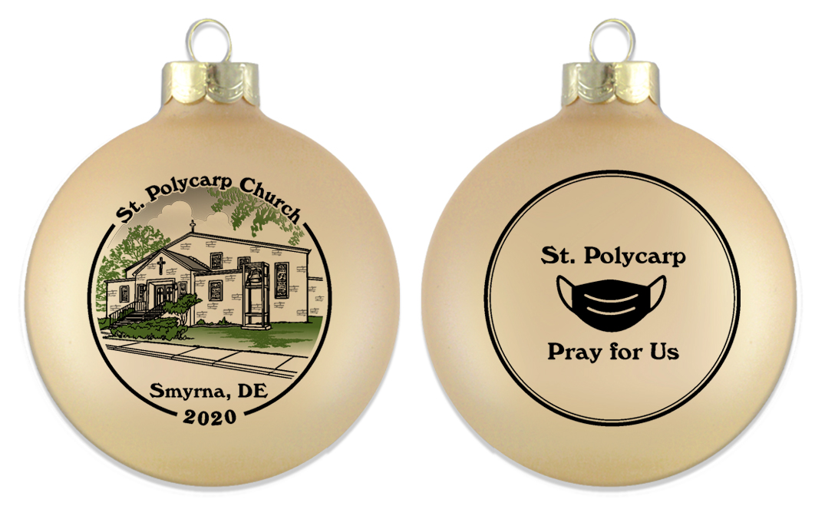

This unique glass Christmas Ornament is 3 1/4” in diameter and comes packaged in its own gift box for safe keeping. Notice the mask on the back. This year is one we’ll never forget.
Our goal is to create a unique series of tree ornaments that depict a new theme each year.
By doing so, we intend to preserve a different aspect of our church. This year’s “Limited Edition” is pictured above. Collect the entire series for your children or simply collect them for your own enjoyment. These beautiful
ornaments are also the perfect gift for friends or family that have moved out of the area.
These ornaments are sure to become a cherished keepsake and heirloom.

Complete the form below for ALL ornaments sold, send to or drop off at St. Polycarp with payment before November 2, 2020. You will be notified when ornaments arrive for pick-up. (ETA…first week of December)

Item | # of Ornaments | Price | Total
2020 Frost Gold Ornament |  | @ $12.00 each
2020 Frost Ornament w/ Brass Hanger |  | @ $15.00 each
Make checks payable to St. Polycarp PSR |  | Grand Total | $

Name Phone_______________________ Email _____________________________

Address City State ________________Zip_______________

Return order form w/payment to the church office by November 2 or mail to 55 Ransom Lane Smyrna, DE 19977
Be sure to mark the envelope…PSR Fundraiser
ONLY return this form w/payment with your total number of ornaments ordered.

