2022 St. Polycarp Church Ornament Order Form
Order yours now! While supplies last!
LIMITED EDITION – only $15 each ($18 w/Gold Hanger)
All proceeds benefit Parish School of Religion (PSR)
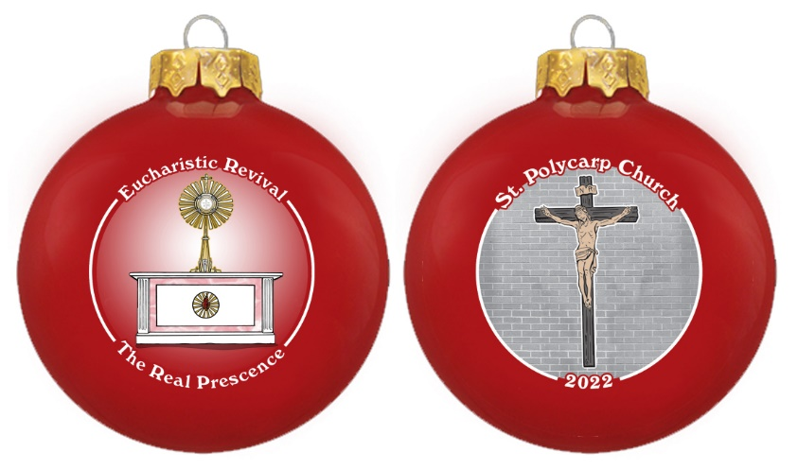
This unique glass Christmas Ornament is 3 1/4” in diameter and comes packaged in its own gift box for safe keeping.
Our goal is to create a unique series of tree ornaments that depict a new theme each year.
By doing so, we intend to preserve a different aspect of our church. This year’s “Limited Edition” is pictured above. Collect the entire series for your children or simply collect them for your own enjoyment. This beautiful
ornament is also the perfect gift for friends or family that have moved out of the area.
These ornaments are sure to become a cherished keepsake and heirloom.

Complete the form below for ALL ornaments sold, send to, or drop off at St. Polycarp with payment before November 6, 2022. You will be notified when ornaments arrive for pick-up. (ETA…first week of December)
You can also place orders through Faith Direct.

Item | # of Ornaments | Price | Total
2022 Gloss Red Ornament |  | @ $15.00 each
2022 Red Ornament w/ Gold Hanger |  | @ $18.00 each
Make checks payable to St. Polycarp PSR |  | Grand Total | $

Name Phone_______________________ Email _____________________________

Address City State ________________Zip_______________

Return order form w/payment to the church office by November 6 or mail to 55 Ransom Lane Smyrna, DE 19977
Be sure to mark the envelope…PSR Fundraiser
ONLY return this form w/payment with your total number of ornaments ordered.

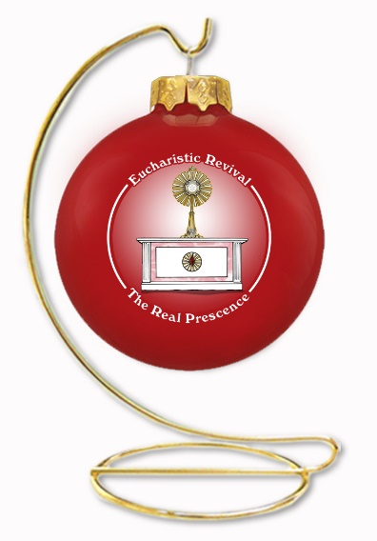
Calling ALL St. Polycarp Families…
Please take part in our…
PSR Christmas Ornament Fundraiser
This Annual Fundraiser is to support our PSR program.
We are selling a limited supply of our “Limited Edition” Christmas Ornaments.
Consider selling to friends and family of the parish, collect the entire series for your children, or simply collect them for your own enjoyment. These beautiful ornaments are the perfect gift for friends or family that have moved out of the area. These ornaments are sure to become a cherished keepsake and heirloom.
This unique Glass Christmas Ornament is 3 1/4” in diameter and comes packaged in its own gift box for safe keeping. (Optional gold hanger available for purchase too)
Our goal is to create a unique series of Christmas tree ornaments that depict a new theme each year. By doing so, we intend to preserve a different aspect of our Church. This year’s theme is “Eucharistic Revival” which was commissioned by the U.S.C.C.B. this year. Pictured on the ornament is St. Polycarp’s very own monstrance, altar, and crucifix. The “Eucharistic Revival” is to elevate the truth through a rediscovery of the Real Presence in the Holy Eucharist.
Start taking orders NOW. All order forms and money must be turned in by November 6. You may also place orders through Faith Direct.
Order yours today while supplies last!
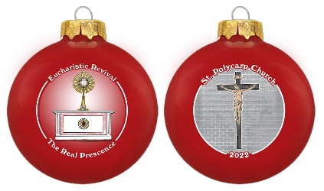
Ornaments will be available the first week of December. You will be notified by phone/email for pick up times.

