Eucharistic Revival – Parishioner’s Survey
The Liturgy Committee would like to know your thoughts on what you would prefer to attend as a session for Eucharistic Revival (deepening our formation) near the Feast of St. Polycarp. Below are some ideas. Please rank them according to your preference (1st, 2nd, etc.).
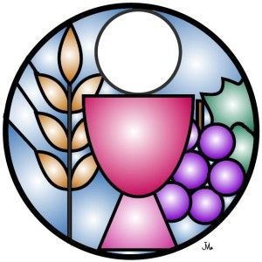

TOPIC WOULD YOU ATTEND? ORDER OF PREFERENCE
(YES or NO) (1st, 2nd, etc.)
40 Hours Eucharistic Adoration ------------- -------------
Parish Mission on the Eucharist ------------- -------------
Sessions on Formed.org on Eucharistic Revival ------------- -------------
The Liturgy Documents ------------- -------------
(Vatican Documents on the Eucharist)
Eucharistic Books for Discussion -------------- -------------

Your suggestions:
1. -------------- -------------
2. -------------- -------------
3. -------------- -------------

Please place your survey in one of the boxes at the entrances
to the Church no later than Sunday, November 20th.

